Use-Case Realization Report (Requirements)
Update Profile

Issue 1.0
Revision History
Date | Issue | Description | Author

Table of Contents
1. Brief Description 4
2. Flow of Events 4
2.1 Standard Flow 4
2.2 Exceptions 4
3. Interaction Diagrams 4
3.1 Domain Collaboration Diagram: Security Management 4
4. Participating Objects 4
5. Derived Requirements 4

Use-Case Realization Report
Update Profile

Brief Description
The use case enables registerd User to update his/her profile.

Flow of Events
The standard flow of events for this use case and any exceptions are described in the following subsections. See section 3.1 for an overview of the participating Actors and Domain Objects.

Standard Flow

Precondition: User has logged in the system

This use case provides the user interface related functionality that will be provided to the User, as follows:
- The User clicks ‘Update Profile’ link and the system is redirected to UserProfileScreen.
- The user profile will be displayed
- The User can update following info:
- Full Name
- Nationality
- Date of Birth
- Gender
- Language Proficiency
- Nationality
- Profession
- Contact
- Address
- The system will perform basic format checking
- After checking is done, system will prompt ‘The information is updated’

Exceptions
The following exceptions have been identified:
- Invalid Information Format. If any of input info is incompatible, system will give a validation summary for user to make corrections

Interaction Diagrams

Domain Collaboration Diagram: Security Management

Participating Objects
:
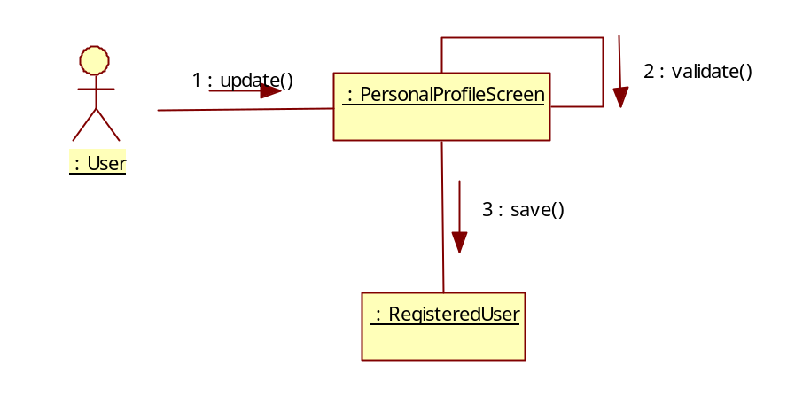

Derived Requirements

